14.1: Write a lambda expression which accepts x and y numbers and return xy.

14.2: Write a method that uses lambda expression to format a given string, where a space is inserted between each character of string. For ex., if input is “CG”, then expected output is “C G”.

14.3: Write a method that uses lambda expression to accept username and password and return

true or false. (**Hint:** Use any custom values for username and password for authentication)

14.4: Write a class with main method to demonstrate instance creation using method reference.

(**Hint:** Create any simple class with attributes and getters and setters)

14.5: Write a method to calculate factorial of a number. Test this method using method reference feature.

**Case Study for Steam API:**

Refer the classes given below to represent employees and their departments.

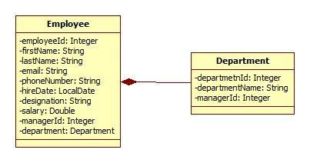

**Figure 20: Class Diagram used for Stream API**

Also refer an EmployeeRepository class which is used to create and populate employee’s collection with sample data.



Department.java Employee.java EmployeeRepository.java

Create an EmployeeService class which queries on collections provided by EmployeeRepository class for following requirements. Create separate method for each requirement. (**Note:** Each requirement stated below must be attempted by using lambda expressions/stream API. It’s mandatory to solve at least 5 questions from following set. However, it is recommended to solve all questions to understand stream API thoroughly).

14.6: Find out the sum of salary of all employees.

14.7: List out department names and count of employees in each department.

14.8:Find out the senior most employee of an organization.

14.9: List employee name and duration of their service in months and days.

14.10: Find out employees without department.

14.11: Find out department without employees.

14.12: Find departments with highest count of employees.

14.13: List employee name, hire date and day of week on which employee has started.

14.14: Revise exercise 10.13 to list employee name, hire date and day of week for employee started on Friday. (Hint: Accept the day name for e.g. FRIDAY and list all employees joined on Friday)

14.15: List employee’s names and name of manager to whom he/she reports. Create a report in format “employee name reports to manager name”.

14.16: List employee name, salary and salary increased by 15%.

14.17: Find employees who didn’t report to anyone (**Hint:** Employees without manager)

14.18: Create a method to accept first name and last name of manager to print name of all his/her subordinates.

14.19: Sort employees by their

* Employee id
* Department id
* First name